Дисциплина: Иностранный язык
Дата: 28.10.2021года
Специальность: 35.02.07 (заочное отделение)
Курс 2, группа 21м
Преподаватель Серёдкина И.А.
Урок № 5-6 (2 курс)
Тема: Местоимения little, a little, much, many, few, a few.
Изучить:
- перевод и употребление местоимений в словосочетаниях и предложениях;
Выполнить упражнения.
Выслать на электронную почту преподавателя: seredkina.i.1970@gmail.com

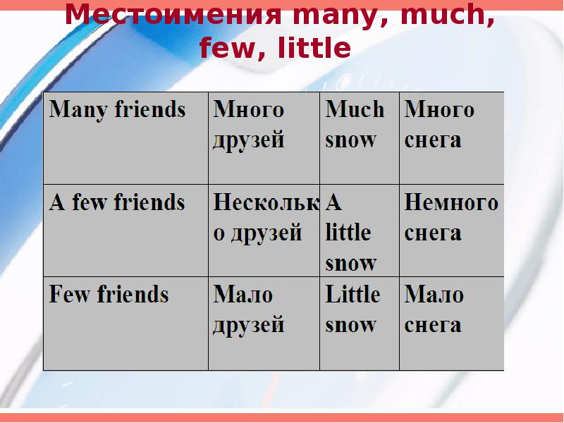
Выполните упражнения:
Упражнение 1. Insert much or many.
1. Do you drink ________coffee? 2. I like reading. I read _________ books. 3. We have _______ lessons of English this year. 4. I can't remember _______ from this text. 5. Do you learn _______ new English words every day? 6. We haven't got ________ bread. 7. I can't spend ________ money on toys.
Упражнение 2 . Вставьте little или few.
- He has got ________ friends. 2. We must hurry. We’ve got very _______ time. 3. The Smiths have ______ money. They aren’t rich. 4. The theatre was almost empty. There were very ________ people there. 5. There was ______ lemonade in the bottle. 6. There is ______ juice in my glass. 7. There are ________ bears in the zoo.
Упражнение 3 . Вставьте «much», «many», «little», «few», «a little» или «a few». Translate the sentences
1. Have you got _____ money? 2. At the conference we met _____ people. 3. If you have _____ spare time, look through this book. You will find ______ stories there which are rather interesting. 4. There are ______ things here which I cannot understand. 5. Shall I bring _____ more chalk? - No, thank you. There is ____ chalk on the desk. I hope that will be enough for our lesson. 6. He had ____ English books at home, so he had to go to the library for more books.

